REGRESSION
Program:
import numpy as np
import matplotlib.pyplot as plt def estimate_coef(x, y):
# number of observations/points n = np.size(x)
# mean of x and y vector m_x = np.mean(x)
m_y = np.mean(y)
# calculating cross-deviation and deviation about x SS_xy = np.sum(y*x) - n*m_y*m_x
SS_xx = np.sum(x*x) - n*m_x*m_x
# calculating regression coefficients b_1 = SS_xy / SS_xx
b_0 = m_y - b_1*m_x return (b_0, b_1)
def plot_regression_line(x, y, b):
# plotting the actual points as scatter plot plt.scatter(x, y, color = "m",
marker = "o", s = 30) # predicted response vector y_pred = b[0] + b[1]*x
# plotting the regression line plt.plot(x, y_pred, color = "g") # putting labels
plt.xlabel('x')
plt.ylabel('y')
# function to show plot
plt.show() def main():
# observations / data
x = np.array([0, 1, 2, 3, 4, 5, 6, 7, 8, 9])
y = np.array([1, 3, 2, 5, 7, 8, 8, 9, 10, 12])
# estimating coefficients b = estimate_coef(x, y)
print("Estimated coefficients:\nb_0 = {} \
\nb_1 = {}".format(b[0], b[1])) # plotting regression line plot_regression_line(x, y, b)
if name == " main ": main()

Output:

Estimated coefficients:
b_0 = -0.0586206896552
b_1 = 1.45747126437

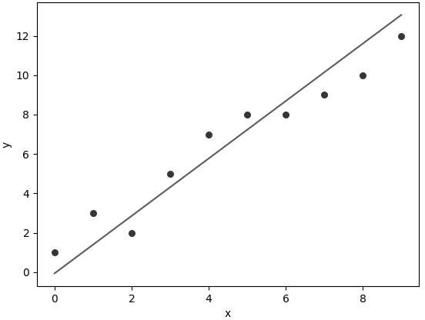

Z-TEST

Program:
# imports import math
import numpy as np
from numpy.random import randn
from statsmodels.stats.weightstats import ztest
# Generate a random array of 50 numbers having mean 110 and sd 15
# similar to the IQ scores data we assume above mean_iq = 110
sd_iq = 15/math.sqrt(50) alpha = 0.05
null_mean =100
data = sd_iq*randn(50)+mean_iq # print mean and sd
print('mean=%.2f stdv=%.2f' % (np.mean(data), np.std(data)))
# now we perform the test. In this function, we passed data, in the value parameter
# we passed mean value in the null hypothesis, in alternative hypothesis we check whether the
# mean is larger
ztest_Score,p_value=ztest(data,value=null_mean,alternative='la rger')
# the function outputs a p_value and z-score corresponding to that value, we compare the
# p-value with alpha, if it is greater than alpha then we do not null hypothesis
# else we reject it. if(p_value < alpha): print("Reject Null Hypothesis")

else:
print("Fail to Reject NUll Hypothesis")

Output:
Reject Null Hypothesis

